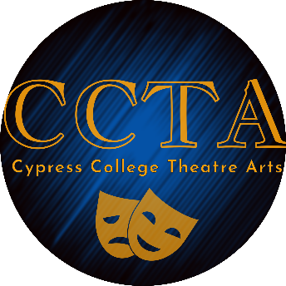

Technical Theatre Program Advisory
Minutes
Friday, May 5th 2023, 12pm-12:30
Zoom Link

In Attendance: Dr. Dower, Margaret Fernandez, Donny Jackson, Austin Allen, Dylan Jackson, Ray Gibson, Spencer Richardson, Aurora Ilog, Melissa Carpenter, Shannon Bicknell,
12:00-12:10 Introductions
12:10-12:15 Donny presented the certificate in Scenic Design
12:15-12:18 Advisory feedback
- Details of the drafting course
- Importance of 3D modeling
12:20 Donny presented the certificate in Stage Management
12:21-12:25 Advisory feedback. Advisors supported all proposed curriculum revisions and additions.
- Options other than music fundamentals were suggested
- Specific design courses suggested, not just Intro.
- Students must learn how to “call” a show

12:26 Wrap up
12:30 Meeting adjourned

Next Meeting: May,2024

